DEPARTMENT OF STATISTICS AND ACTUARIAL SCIENCE
ASTA 607: COMPUTATIONAL STATISTICS I
Divine Komla Kpe (22424375)
Data set up
data("crabs")
load("crabs")
install.packages("MASS")
library(MASS)
data(crabs)

Q1: Data Structure
- Description of Dataset
The dataset contains 200 observations on crabs of the species Leptograpsus variegatus. It was collected to study morphological differences according to: Species (colour form) and Sex (male or female). The variable includes Frontal Lobe (FL), Rear Width (RW), Carapace Length (CL), Carapace Width (CW) and Body Depth (BD) with all five morphological measurements being continuous and measured in millimetres (mm).

- Structure of dataset
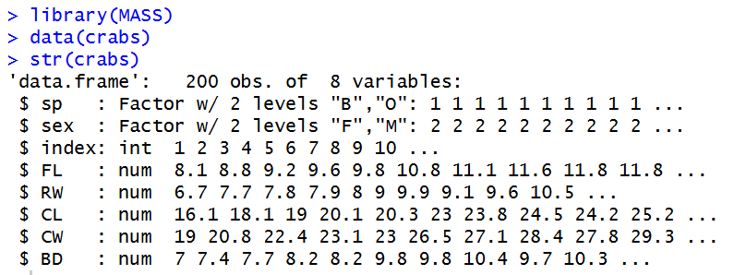

- Frequency for species and sex
group_table <- table(crabs$sp, crabs$sex)
F M
B 50 50
O 50 50

- Bar chart
Grouped bar chart

barplot(group_table,
beside = TRUE,
col = c("skyblue", "salmon"),
legend = rownames(group_table),
main = "Group Composition of Crabs by Species and Sex",
xlab = "Sex",
ylab = "Frequency")

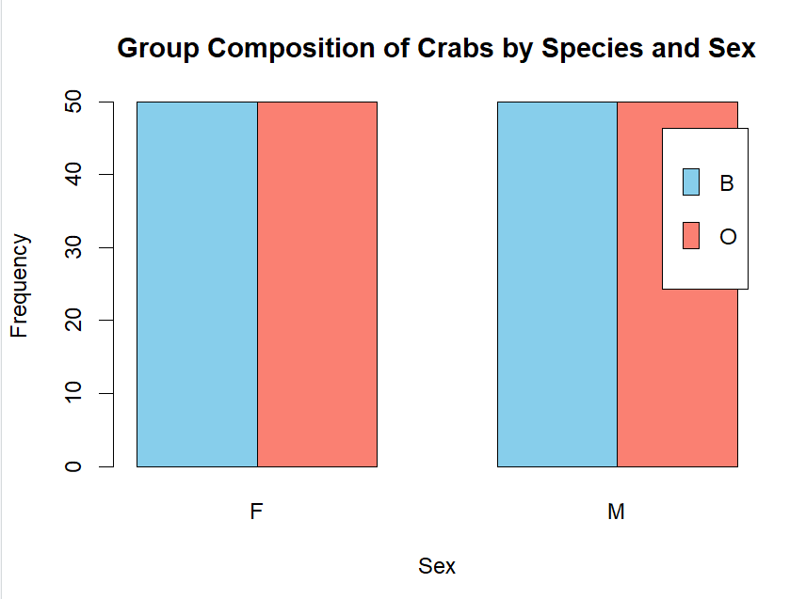
- The dataset is balanced since it has equal numbers of observations per species (100 each).

Q2: Distribution of Body Depth
- Boxplot
crabs$Group <- interaction(crabs$sp, crabs$sex)

boxplot(BD ~ Group,
data = crabs,
col = c("skyblue", "deepskyblue", "salmon", "red"),
main = "Body Depth (BD) by Species and Sex",
xlab = "Species and Sex",
ylab = "Body Depth (mm)"))

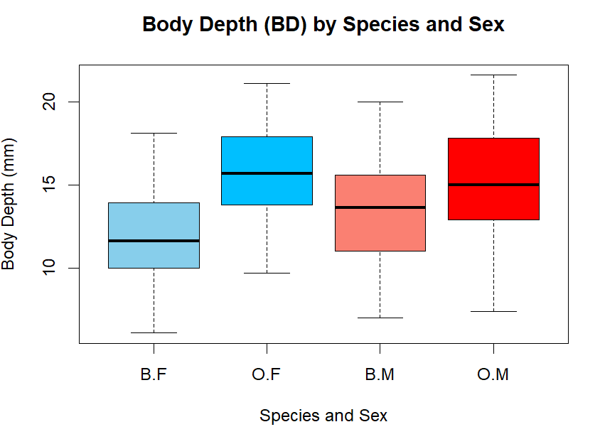

- Outliers
From the boxplots, no outlier appears that would heavily distort group comparisons.
Central Tendency: Males generally have higher median body depth than females within each species. The smallest group is Blue Females, and the largest groups are Orange Females and Orange Males.
Variability: Orange groups (O.F and O.M) show slightly larger spread. Overall variability across groups is fairly similar.

Q3: Caraspace Length Distribution
- Histogram
par(mfrow = c(1, 2))
hist(crabs$CL[crabs$sp == "B"],
main = "Carapace Length (Blue Species)",
xlab = "Carapace Length (mm)",
ylab = "Frequency",
col = "skyblue",
border = "black")

hist(crabs$CL[crabs$sp == "O"],
main = "Carapace Length (Orange Species)",
xlab = "Carapace Length (mm)",
ylab = "Frequency",
col = "salmon",
border = "black")

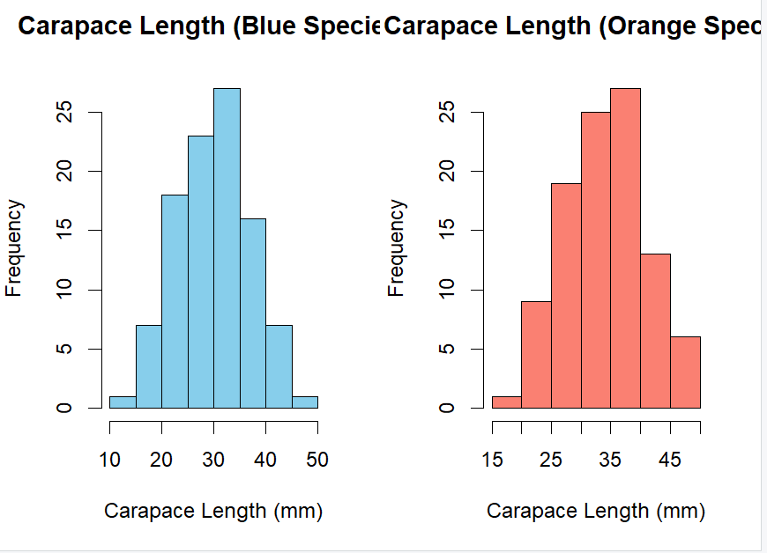

- Comment on Skewness and Modality
- Skewness: The distribution for the Blue Species appears approximately symmetric, with no pronounced long tail on either side. The distribution for the Orange Species also appears approximately symmetric, with the tails appearing fairly balanced.
- Modality: Both distributions are unimodal with single prominent peak.

Q4: Mean of Measurement
- Mean of each measurement.
mean_table <- aggregate(
cbind(FL, RW, CL, CW, BD) ~ sp + sex,
data = crabs,
FUN = mean
)
mean_table

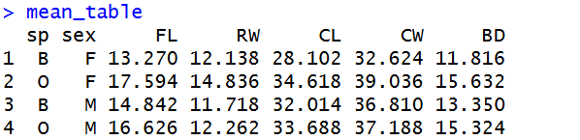

- Grouped bar chart
mean_table <- aggregate(
cbind(FL, RW, CL, CW, BD) ~ interaction(sp, sex),
data = crabs,
mean
)
mean_table

barplot(t(as.matrix(mean_table[, -1])),
beside = TRUE,
col = rainbow(4),
legend.text = mean_table[, 1],
args.legend = list(x = "topright"),
main = "Mean Morphological Measurements by Species and Sex",
xlab = "Measurement",
ylab = "Mean (mm)")

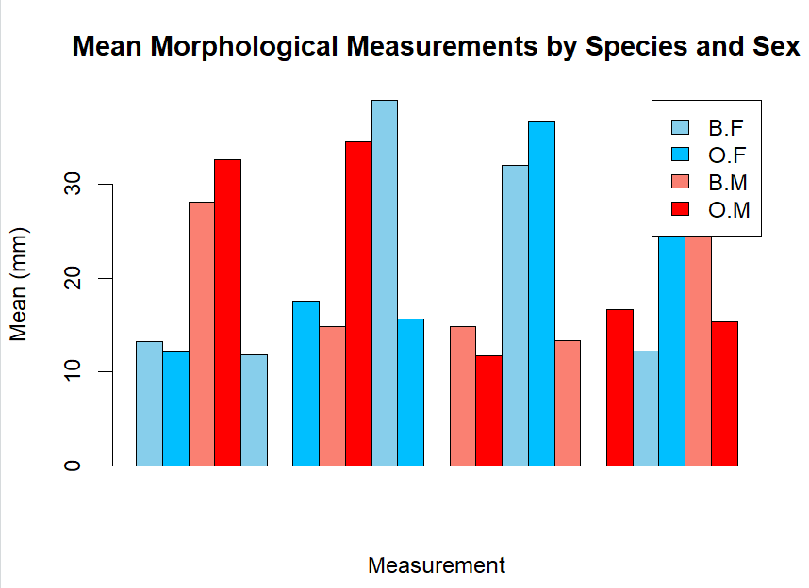

- Species Difference: Comparing Blue-Orange species within the same sex, CL shows the largest species difference, especially among females, 6.516 mm.
Sex Variation: Comparing Male-Female within each species, RW shows the smallest sex variation (-2.574)

Q5: Relationships
- Scatterplot
pairs(crabs[, c("FL", "RW", "CL", "CW", "BD")],
main = "Scatterplot Matrix of Morphological Measurements",
pch = 19,
col = "steelblue")

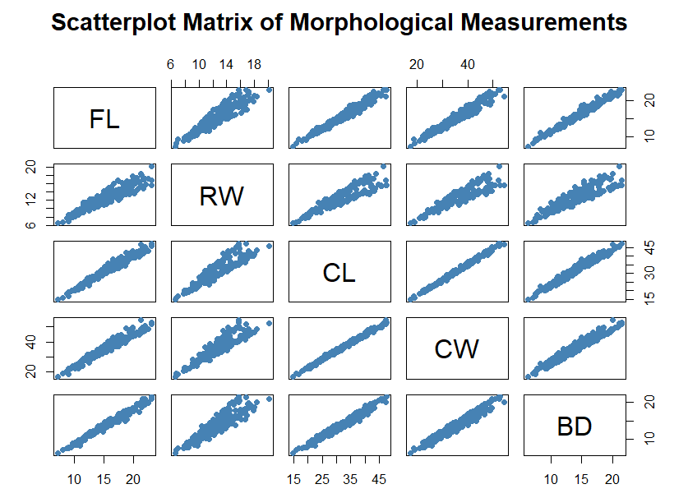
- Nature of relationships
- Strength: Across almost all pairs of variables, very strong positive linear relationships among all five measurements. In particular, CL and CW show an almost perfect linear relationship.
- Nature: All relationships are positive and the patterns linear

Q6: Report
This report presents a descriptive statistical analysis of the crabsdataset from the MASS package. The dataset contains morphological measurements of 200 crabs of the species, Leptograpsus variegatus, collected at Fremantle, W. Australia. The analysis mainly explores differences in morphology by species (Blue “B” and Orange “O”) and sex (Male “M” and Female “F”), and to examine relationships among five variables in a continuous measurement. These are Frontal Lobe (FL), Rear Width (RW), Carapace Length (CL), Carapace Width (CW) and Body Depth (BD), with all five morphological measurements measured in millimetres (mm).

The dataset is perfectly balanced: 100 Blue and 100 Orange crabs and 100 Females and 100 Males, and therefore, observed differences in Carapace Length and other measures can be attributed to biological differences rather than unequal group sizes.
Group means revealed systematic differences across both species and sex. For example, Carapace Length showed the following means (mm): Blue Female: 28.10, Blue Male: 32.01, Orange Female: 34.62 and Orange Male: 33.69. Two clear patterns emerge: 1) Orange crabs tend to have larger measurements than Blue crabs and across sex, Males generally exhibit larger body dimensions than females within species.
Among all five measurements, Carapace Length exhibits the largest species difference, particularly among females (difference ≈ 6.5 mm between Orange and Blue) with Carapace Width showing a similarly strong pattern. In contrast, Rear Width demonstrates the smallest sex variation, with minimal differences between males and females within species.
Side-by-side boxplots of Body Depth by Species and Sex revealed clear separation between Blue and Orange crabs as Males generally have greater body depth than females, with no extreme outliers. Impliedly, the overall body size varies more strongly by species than by sex, though both factors influence morphology.
Histograms of Carapace Length for each species indicate approximately unimodal distributions with rough symmetry with no pronounced long tail on either side, reinforcing the species effect observed in the mean comparisons.
The scatterplot matrix of FL, RW, CL, CW, and BD reveal strong positive linear relationships between all pairs of variables, particularly strong association between CL and CW. There was no evidence of nonlinear patterns. These results indicate that the variables appear to measure closely related aspects of overall body size with larger crabs tending to be proportionally larger in all measured dimensions.
This analysis demonstrates clear morphological differentiation between Blue and Orange crabs, as well as differences in sex

